Hospitality Management System
Guest and Reservation Subsystem
Software Design and Architecture | Project Progress (Revised)
Phoo Pwint Cho Thar - 67011755
Hsu Myat Shwe Sin - 67011118
Thiri Thaw - 67011731
San Aung - 67011725
La Min Maung - 67011615
Phone Myat Pyae Sone - 67011642

1. Problem Description

1.1 The Problem
Guests now book rooms online, expect fast confirmation, and compare hotels on service quality as much as on price. Yet in many hotels the work of handling guests and reservations still depends on separate tools and paper forms. This causes the following problems:
- Double booking. The same room is sometimes booked twice because room availability is kept in several places and is not updated in real time.
- Unreliable availability and rates. Guests and Front Desk Agents cannot quickly see which rooms are free and at what rate, so searching is slow and answers can be out of date.
- Repeated guest data entry. Staff re-enter the same guest information many times. Guest records become duplicated or inconsistent, and a returning guest’s details, stay history and loyalty tier are hard to find.
- No temporary hold while booking. While one person is completing a booking, the same room can be taken by someone else, so the booking fails at the last step.
- Manual changes and cancellations. Modifying or cancelling a reservation is done by hand. Availability and price are not always re-checked, released rooms are not freed promptly, and deposits and refunds are applied inconsistently.
- Late or missing confirmations. Guests do not always receive a reliable confirmation of their booking.
- Scattered personal data. Guest contact and ID document details are spread across paper forms and tools, which makes them hard to protect, export or delete.
- Slow and fragile system. The main application runs slowly during busy periods, and one error can stop all departments, including reservations.

1.2 Project Scope
Following our supervisor’s feedback, this report focuses on one use case only: the Guest and Reservation subsystem. It covers guest profiles, room availability search, and creating, modifying, cancelling and looking up reservations. Front desk check-in/check-out, billing and folios, housekeeping and maintenance, and administration and reporting are outside the scope of this report.

1.3 System Capabilities
Within this scope, the system should be capable of:
- Collecting and storing information about guests, including contact details, ID document details, preferences and loyalty tier
- Searching room availability and rates in real time by hotel, dates, number of guests and room type
- Creating reservations with a deposit and a temporary room hold (10 minutes) while the booking is completed
- Modifying and cancelling reservations, re-checking availability, recalculating the price, applying the cancellation policy and releasing room inventory
- Looking up guest profiles, stay history and reservations by confirmation number or guest information
- Sending a reservation confirmation to the guest by email or SMS
- Authenticating users and restricting each screen and action by role (Guest, Front Desk Agent, Manager)
- Reading hotel, room type and rate plan data needed for search and pricing (maintaining this data is outside this report’s scope)

1.4 Business Benefits
- Faster and more accurate reservations, with double booking eliminated by a single source of truth for room inventory
- Guest information entered once and reused for searching, booking and lookup, so there is less re-entry and fewer duplicate records
- Immediate and reliable booking confirmations, with consistent handling of modifications, cancellations, deposits and refunds
- Timely, accurate availability and rate information for guests and staff
- Lower operating risk and cost: services scale independently in peak season, a failure in one service does not stop the others, and new features can be released without redeploying the whole system

2. Requirements Models

2.1 Functional Requirements
ID | Requirement
FR-1 | The system shall allow guests and Front Desk Agents to create and update guest profiles, including name, phone number, email address, address, identification document, preferences, and other relevant guest information.
FR-2 | The system shall allow authorized Front Desk Agents and Managers to search for guest profiles and stay history using information such as name, phone number, email address, or loyalty number.
FR-3 | The system shall allow guests and Front Desk Agents to search for available rooms by hotel, check-in date, check-out date, number of guests, and room type. The system shall display available room types and applicable rates.
FR-4 | The system shall allow guests and Front Desk Agents to create reservations by selecting a room type and rate, entering or selecting guest information, and providing the required deposit or payment information. The system shall temporarily hold the selected room while the booking is completed and generate a reservation confirmation.
FR-5 | The system shall allow guests and Front Desk Agents to modify an existing reservation, including its dates, room type, or number of guests. The system shall re-check room availability and recalculate the applicable price before confirming the modification.
FR-6 | The system shall allow guests and Front Desk Agents to cancel reservations. The system shall release the associated room inventory, apply the configured cancellation policy, and initiate a refund when applicable.
FR-7 | The system shall allow guests and Front Desk Agents to retrieve reservation details using a confirmation number or guest information.

2.2 Non-Functional Requirements
ID | Quality | Requirement
NFR-1 | Performance | The system shall provide timely responses for room availability searches and reservation operations under normal operating conditions.
NFR-2 | Scalability | The system shall support horizontal scaling of individual services to handle increases in user activity without requiring all services to be scaled simultaneously.
NFR-3 | Security | The system shall protect user accounts and system resources through secure authentication, authorization, and communication mechanisms. Access to system functions shall be controlled according to user roles.
NFR-4 | Privacy | The system shall protect guest personal information and support applicable privacy and data-protection requirements, including guest consent, data export, deletion, and retention policies.
NFR-5 | Reliability | The system shall protect data from service failures through automated backups and reliable message processing.
NFR-6 | Interoperability | The system shall provide standardized interfaces for communication between services and external systems.
NFR-7 | Maintainability | Each microservice shall be independently maintainable, built, tested, versioned, and deployed without requiring unrelated services to be redeployed.
Section 3 explains how the microservice architecture was chosen to satisfy these requirements.

2.3 Models

2.3.1 Use Case Diagram: Guest and Reservation System
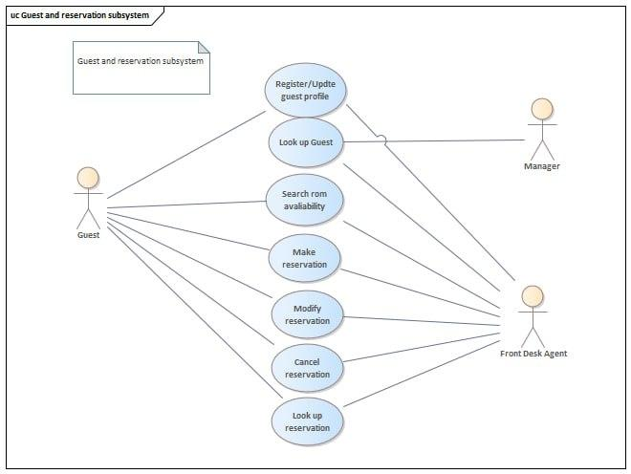
Figure 1. Use case diagram of the Guest and Reservation subsystem
Use case | Actors | Description
Register/Update Guest Profile | Guest, Front Desk Agent | Allows a Guest to create or update their profile, or a Front Desk Agent to do so on the guest’s behalf.
Look Up Guest | Front Desk Agent, Manager | Allows a Front Desk Agent or Manager to find a guest’s profile and reservation history.
Search Room Availability | Guest, Front Desk Agent | Allows a Guest to search for available rooms by date, room type, and number of guests.
Make Reservation | Guest, Front Desk Agent | Allows a Guest to book a room through the web/mobile interface, or a Front Desk Agent to create one on their behalf.
Modify Reservation | Guest, Front Desk Agent | Allows a Guest or Front Desk Agent to change the dates, room type, or details of an existing reservation.
Cancel Reservation | Guest, Front Desk Agent | Allows a Guest or Front Desk Agent to cancel an existing reservation.
Look Up Reservation | Guest, Front Desk Agent | Allows a Guest or Front Desk Agent to view the details and status of a reservation.

2.3.2 Class Diagram
The class diagram below shows only the classes needed by the Guest and Reservation subsystem. A Guest makes many Reservations and receives Notifications. Each Reservation books one RoomType and may have deposit Payments. Each RoomType belongs to a Hotel and is priced by one or more RatePlans.
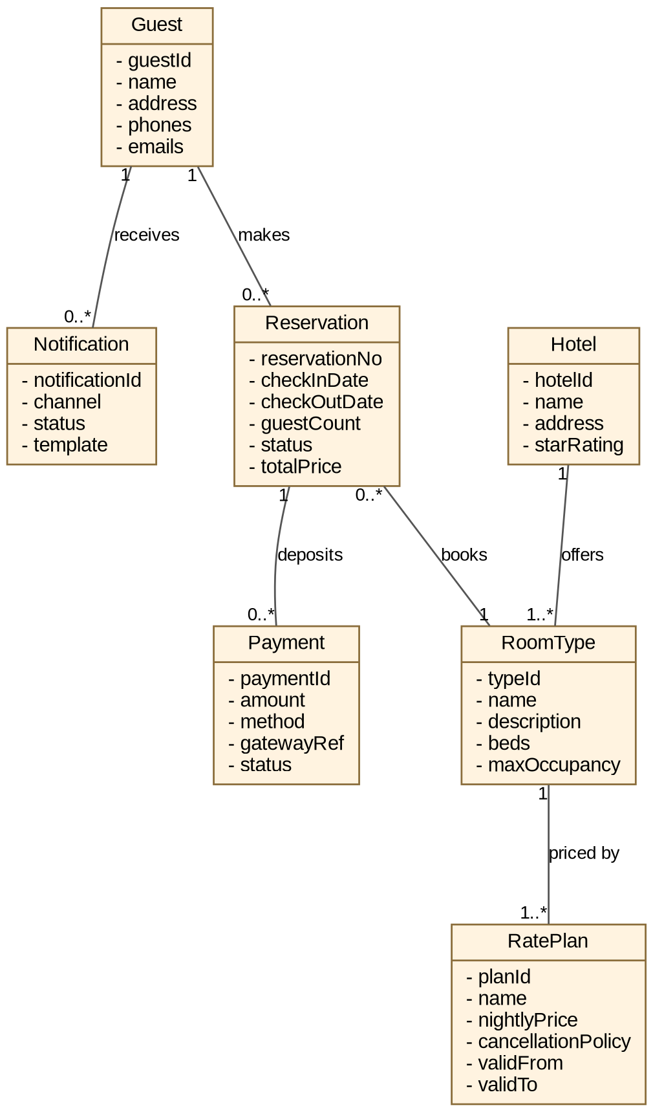
Figure 2. Class diagram of the Guest and Reservation subsystem

2.3.3 Activity Diagram
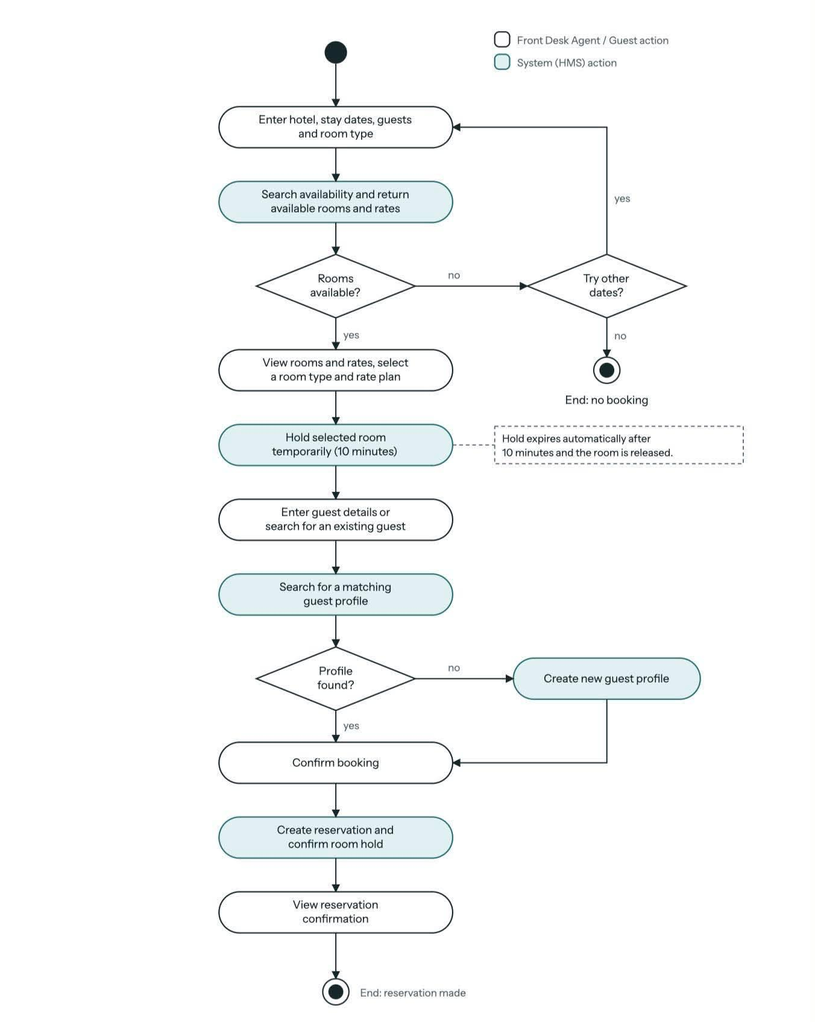
Figure 3. Activity diagram: make a reservation

2.3.4 Sequence Diagrams
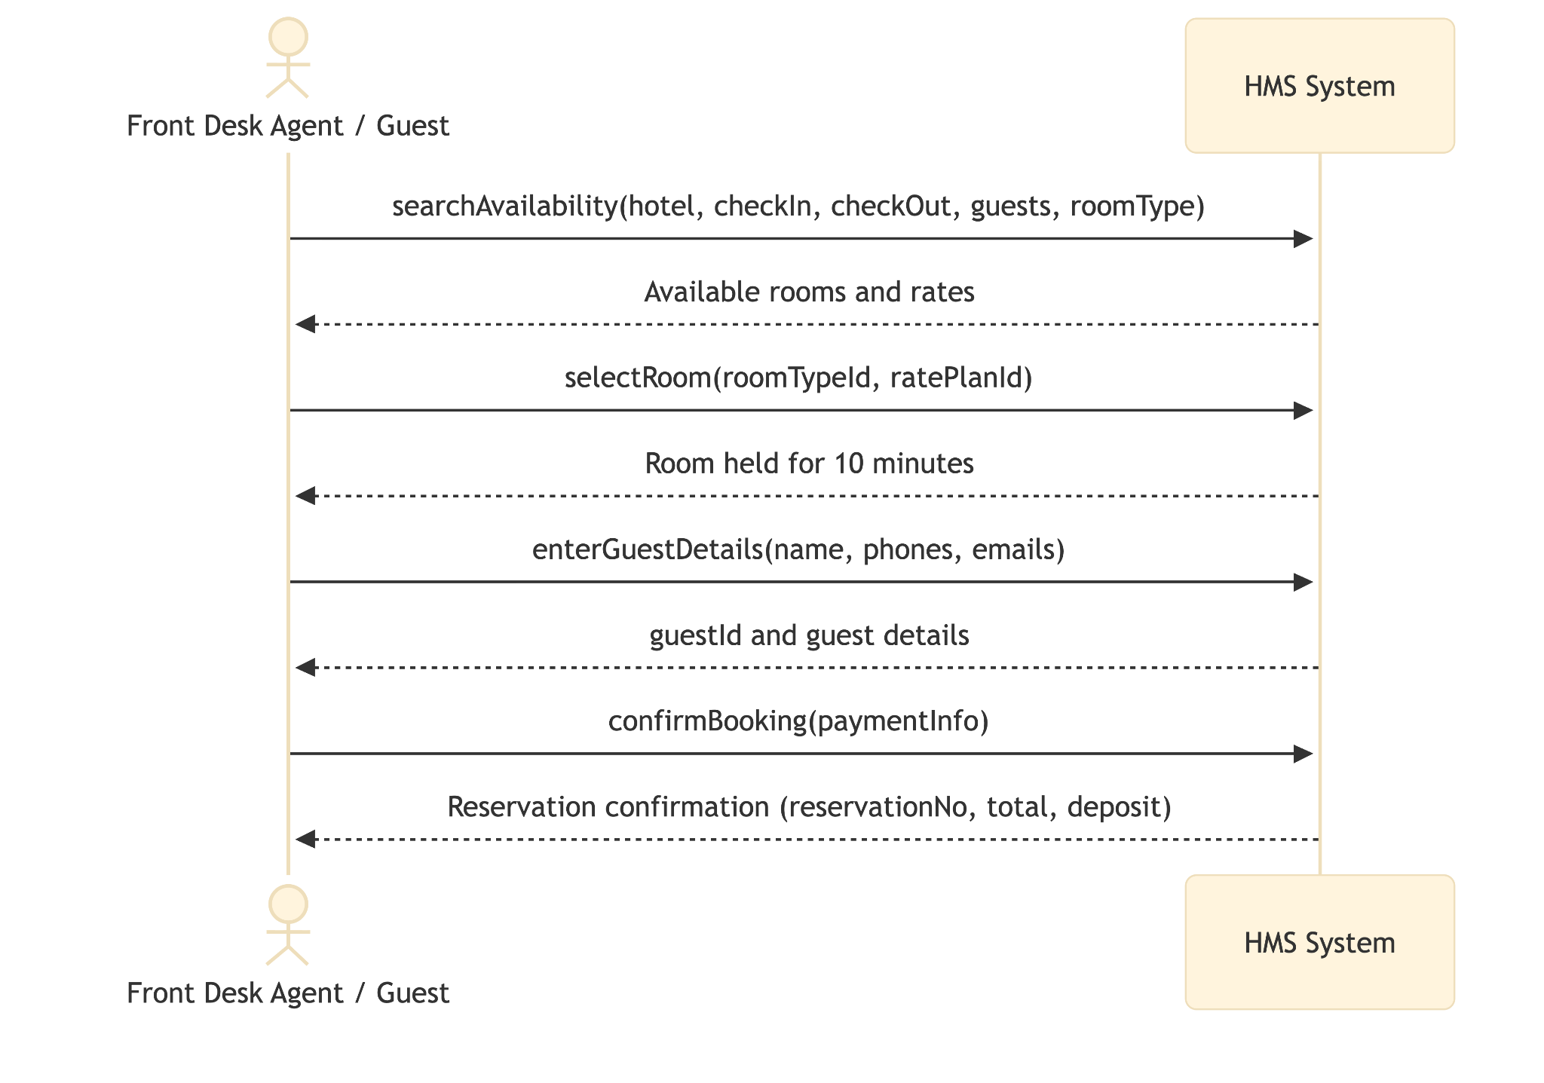
Figure 4. Sequence diagram: make reservation
Figure 5 shows the same booking inside the microservice architecture. The Reservation Service coordinates the other services as a saga: if the deposit is declined, the room hold is released as a compensating action.
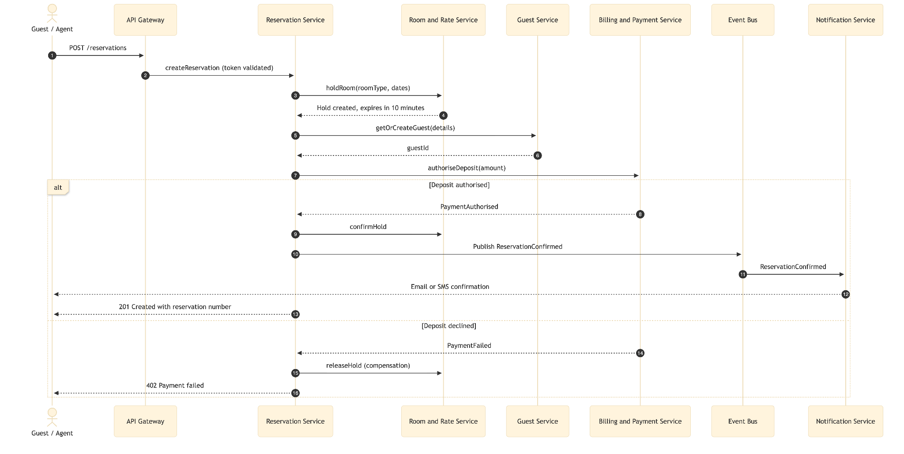
Figure 5. Booking saga across services

2.3.5 User Interface: Reservations Management
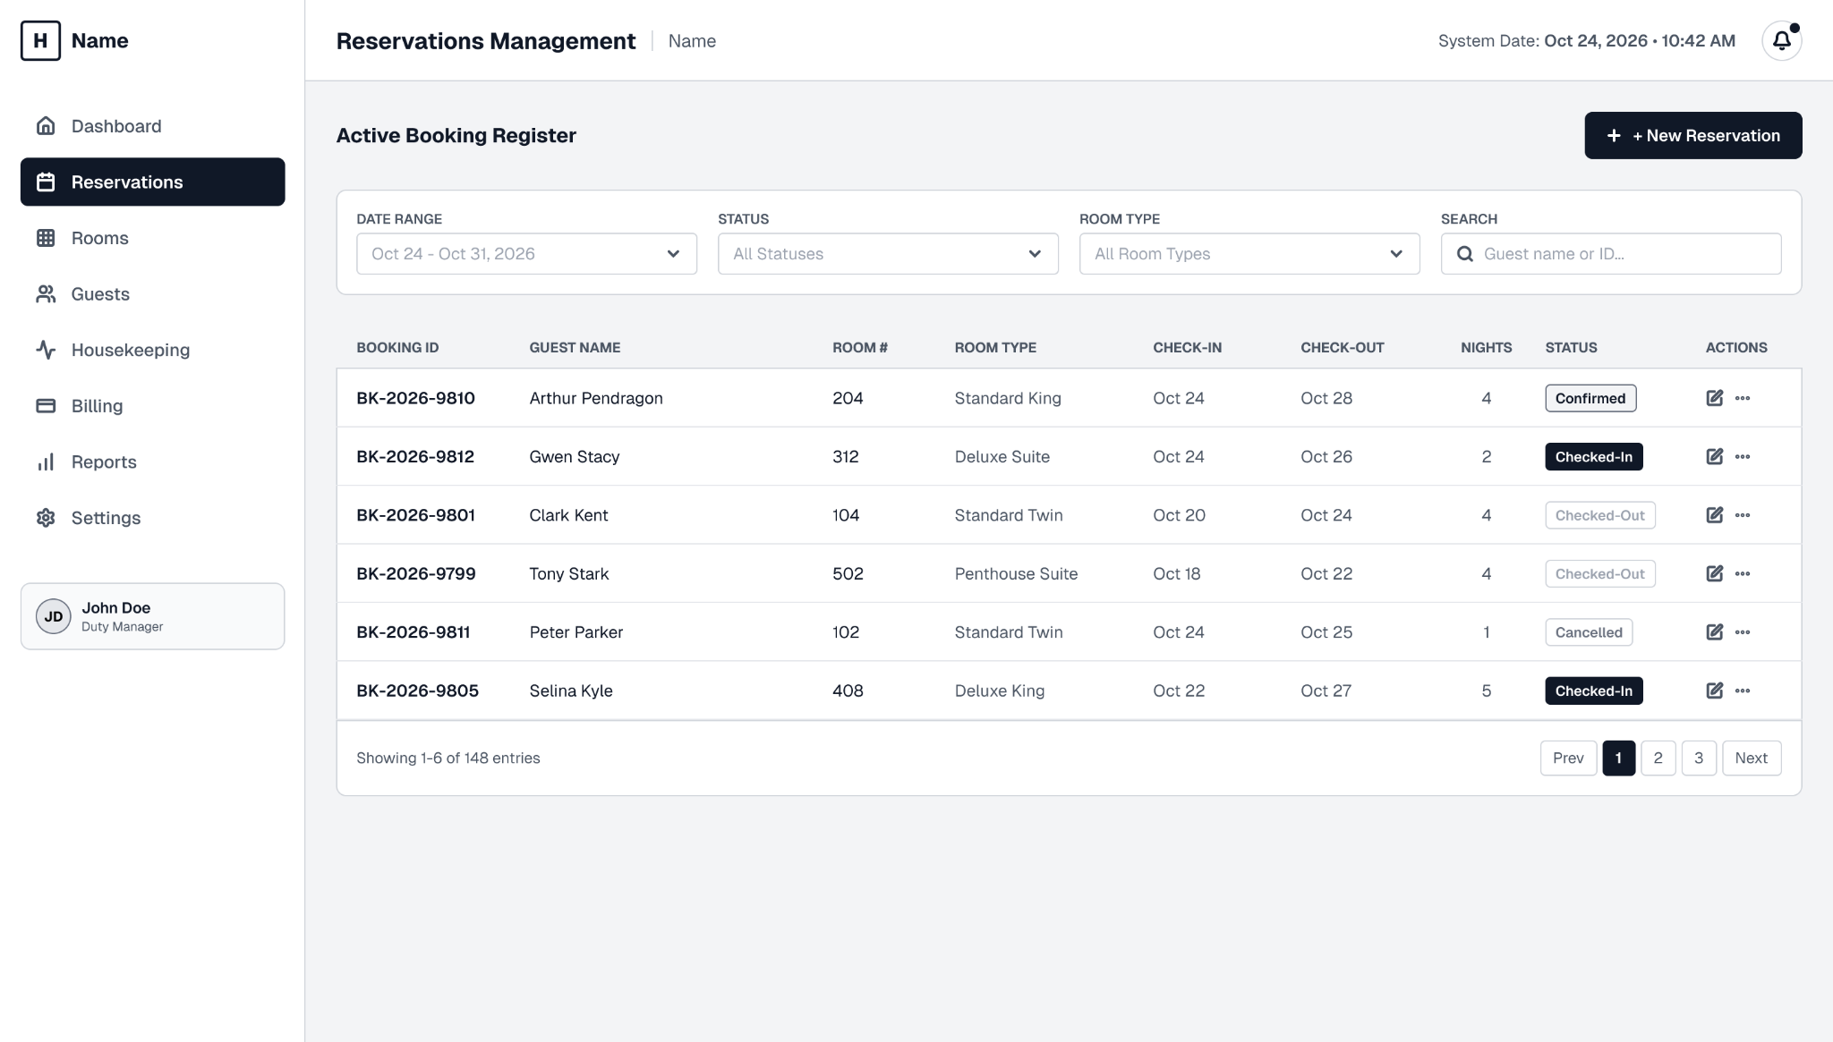
Figure 6. Reservations Management screen

3. Architecture and Rationale

3.1 Architectural Style: Microservices
We deploy the system as a set of microservices. Each business capability is built, scaled and released independently, and communicates through standard interfaces and asynchronous events. For the Guest and Reservation subsystem, the main services are the Guest Service, Reservation Service, Room and Rate Service, Billing and Payment Service (for deposits and refunds), and Notification Service, behind an API Gateway.
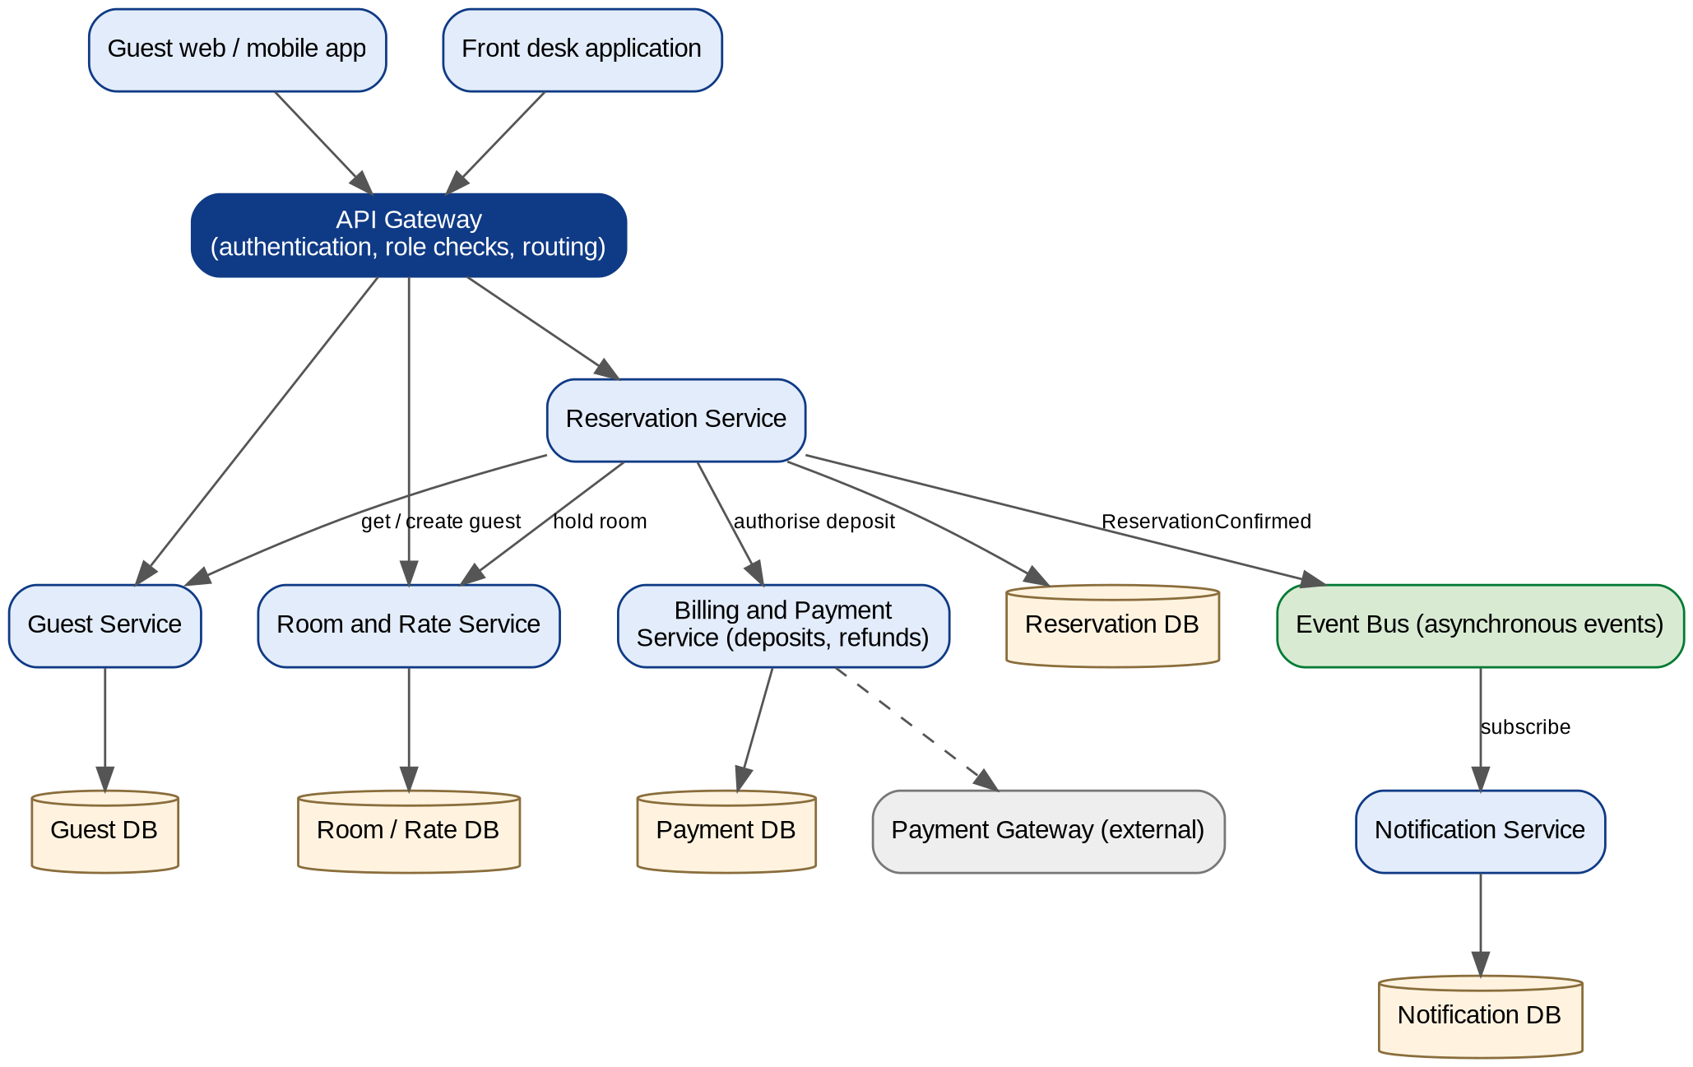
Figure 7. Microservice architecture for the Guest and Reservation subsystem

3.2 Why Microservices?
The problems in Section 1.1 and the non-functional requirements in Section 2.2 both point to this architecture. Two problems in particular drove the decision: one error stopping every department, and the main application slowing down at busy times. A single large application cannot isolate failures or scale only the busy part. Microservices can.
NFR | Need | How microservices satisfy it in our design
NFR-1 | Timely responses | Availability search is read-heavy. The Room and Rate Service owns inventory and rates and is tuned separately, so searches stay fast while reservations are being written.
NFR-2 | Horizontal scaling | Search and booking traffic peaks in busy seasons. Only the Room and Rate and Reservation services are scaled, not the whole application, which addresses the slow-at-peak problem.
NFR-3 | Security | The API Gateway is the single entry point. It validates the user’s token once and enforces role-based access (Guest, Front Desk Agent, Manager) before a request reaches any service.
NFR-4 | Privacy | Personal data and ID document details live only in the Guest Service and its own database. Consent, export and deletion are implemented in one place, and other services keep only the guestId.
NFR-5 | Reliability | Each service has its own database that is backed up separately. The Event Bus delivers events such as ReservationConfirmed reliably, and the booking saga releases the room hold if the deposit fails. A failure in notifications does not stop bookings.
NFR-6 | Standard interfaces | Services expose standard APIs through the gateway (for example POST /reservations) and publish events on the Event Bus. The same APIs serve the web, mobile and front desk applications.
NFR-7 | Independent maintenance | Each service has its own code, tests, version and deployment pipeline, so a change to one service (for example notification templates) does not require redeploying the others.

Microservices also fix the double-booking problem directly: the Room and Rate Service is the only owner of room inventory, so every channel sees the same availability and the same temporary holds.

3.3 Services in Scope
Service | Responsibility | Data owned
API Gateway | Single entry point; authentication and role checks; request routing | None (stateless)
Guest Service | Guest profiles, ID details, preferences and loyalty tier; search and lookup; get-or-create guest | Guest DB
Reservation Service | Create, modify, cancel and look up reservations; coordinates the booking saga | Reservation DB
Room and Rate Service | Hotels, room types, rate plans, real-time availability and 10-minute room holds | Room / Rate DB
Billing and Payment Service | Authorises deposits and issues refunds through the external payment gateway | Payment DB
Notification Service | Sends confirmation email or SMS when it receives ReservationConfirmed | Notification DB
Event Bus | Asynchronous, reliable delivery of events between services | Message store

3.4 Trade-offs
Microservices add complexity. Data is spread across services, so consistency across them is eventual rather than immediate, and calls between services add network delay. We manage this with the saga pattern and compensating actions (releasing the hold), asynchronous events, and automated deployment and monitoring. We accept these costs because independent scaling, fault isolation and independent releases are central to the problems and requirements of this project.

4. Implementation Plan and Status
To keep the implementation manageable, we build every service in the architecture but keep the supporting services deliberately thin. Core services are fully implemented. Billing and Notification are simplified, and the external payment gateway is simulated. This does not change the architecture or the saga design.

4.1 Service Implementation Status
Service | Level | What is built and what is simulated
API Gateway | Full | Routing, token validation and role checks (Guest, Front Desk Agent, Manager).
Guest Service | Full | Create/update profiles, search and lookup, get-or-create guest. Own database.
Reservation Service | Full | Create, modify, cancel and look up reservations; coordinates the booking saga, including the compensating action.
Room and Rate Service | Full | Availability and rate search, room types and rate plans, temporary room holds that expire after 10 minutes.
Billing and Payment Service | Simplified | Only authorizeDeposit(amount) and refund(paymentId). The external payment gateway is a stub that approves by default and can be switched to decline for testing.
Notification Service | Simplified | Subscribes to ReservationConfirmed and sends a test email or logs the message. No template management.
Event Bus | Lightweight | A single lightweight message broker (or a simple queue) used only for events such as ReservationConfirmed.

4.2 Deployment Approach
- All services run together with Docker Compose, one container per service.
- Each service has its own small database (for example SQLite or a Postgres container), so data stays separated between services.
- Production-grade security and scaling are not implemented. They are described in Section 3 as the target design.

4.3 Demonstration Scenarios
The prototype will demonstrate the architectural points from Section 3 with three scenarios:
- Successful booking. Search, hold, deposit authorized, reservation confirmed, notification sent.
- Declined deposit. The stub gateway declines, the Reservation Service releases the room hold, and the user receives a payment-failed response (reliability, NFR-5).
- Notification service down. The booking still succeeds and the confirmation is delivered later from the event bus (fault isolation, NFR-5 and NFR-7).

